iii. Cost Savings Case Studies

This 17 year old patient has a $4,000 family deductible! And had a $30.00 copay for this visit.
Dr. Corba has developed age specific validated tool for ADHD for screening, diagnosing and treating ADHD and any co-existing conditions like anxiety, depression, OCD, panic disorder.
For an affordable screening fee, you can have 30-60 minute unlimited follow up appointments AND after hours texting/emailing for urgent issues with NO COPAY, NO DEDUCTIBLE.
The cost = $10.00/month (with parent signed up, $25.00 without parent as a member).
Check us out at greenhillsdirectfamilycare.com
610-530-9155
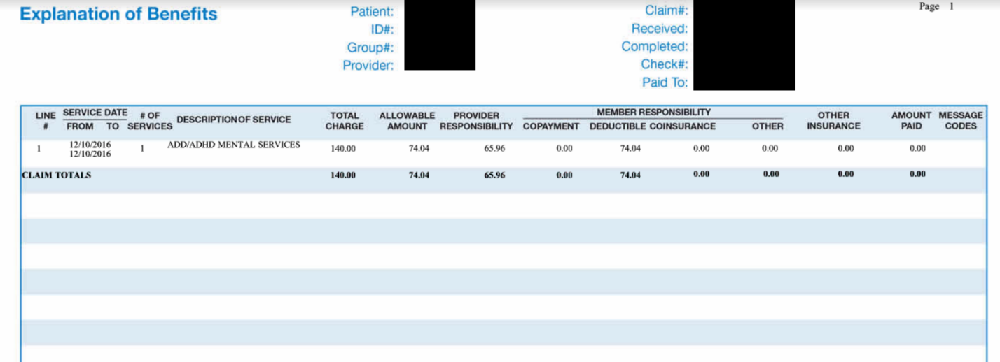

46 year old pays $75.00/mo for DPC membership.
With that she gets...
Free spacer for asthma inhalers, savings on a nebulizer with tubing for $28.80 through our wholesale supplier, gets a free sample for Asmanex inhaler for trial and saves on an rx for Fish oil 1000 mg #120 tabs for $5.52 using our in-house pharmacy. And a 30 minute visit with NO-COPAY, NO DEDUCTIBLE!
AND you can submit cost for supplies/meds to HSA, HRA, FSA, out-of-network deductible!
What would all of this cost otherwise?
www.greenhillsdirectfamilycare.com

#Employers! How can you spend your dollars more wisely with DPC? Here's how!
- #DPC can reduce ER/Urgent Care visits by up to 90%!
- 95% savings on medications
- 95% savings on labs (labs for annual wellness $20-$30)
- Better attention, time, coordination, cut down on hospitalizations, special visits, unnecessary testing.
For more info, click on this link to our Town Hall prese for employers:
https://1drv.ms/p/s!AsV571PpiDfljGopMzmSDZ5lYhEF
And for pricing, more details check out our website! www.greenhillsdirectfamilycare.com

What do we currently spend on health care? Here's the jaw clenching breakdown...
- In 2014, the average spent on pharmaceuticals in the US was $1000,00 per person.
- Up to 95% discount on medications in #DPC
- In 2013, the average cost of an ER visit was $1,233.00 (average rent was $871.00). A headache in this NIH study could cost as high as $17K if seen in the ER!!!
- Average cost of an Urgent Care visit $150.00-$200.00
Cut WAY DOWN on these inflated costs!
www.greenhillsdirectfamilycare.com

This is how it's done here at #GHDFC!!
37 y/o NEW patient with no PCP for 2 years. Scheduled her for 1 1/2 hour appointment for complete physical, PAP (YES-both done in SAME VISIT!), EKG. The fair market value for these services is approx $330.00 through traditional insurance. BUT this all included in $50.00 monthly membership fee with NO COPAY, NO DEDUCTIBLE, unrestricted visits.
Oh, and her fasting blood work totals less than $30.00!
www.greenhillsdirectfamilycare.com

An EOB for 14 year old ADHD check up with doctor billed through regular insurance. One 15 minute visit costs $140.00 and his parents have to pay $74.04 toward their $4,000 deductible!
For $10.00/ month (with parent signed up), and Dr. Corba's in depth validated screening/treatment program for ADHD, this patient could get unlimited 30 min visits, access after hours via text, email, video visits.#DirectPrimaryCare
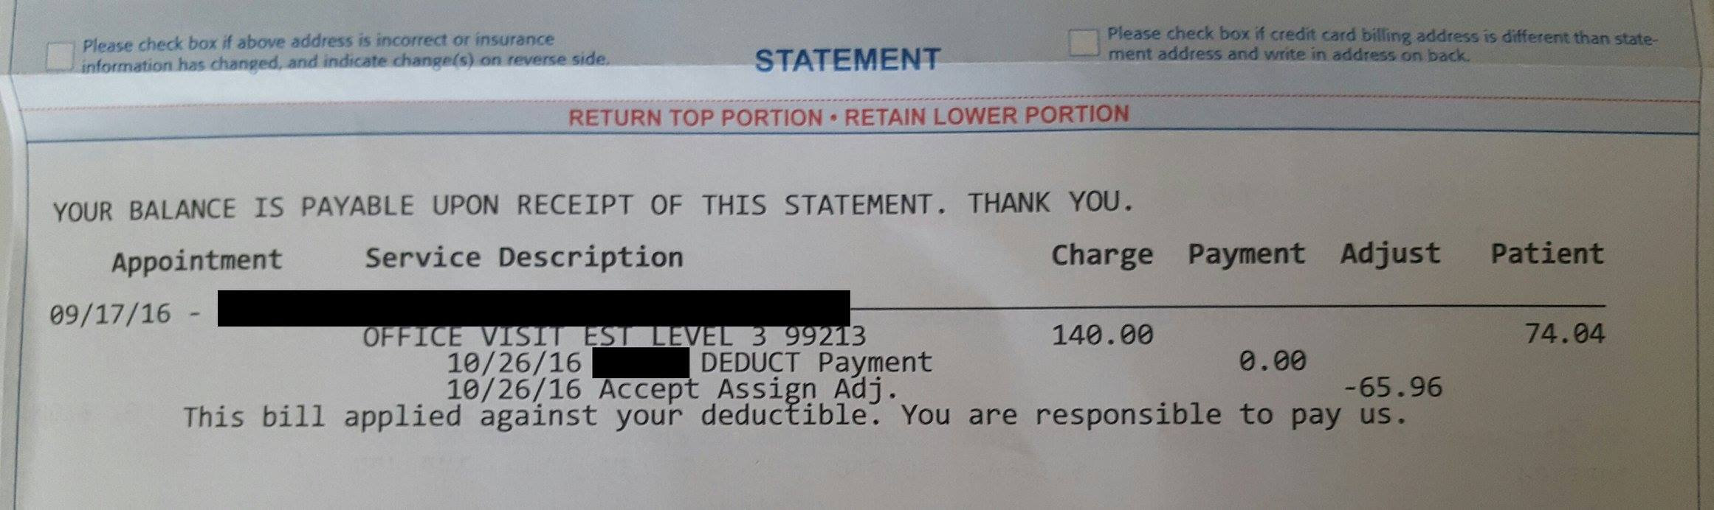

We have another #GHDFC Case Study for you!
Patient: 35 year old female with history of high blood pressure, high cholesterol, hypothyroidism, depression, on total of 6 medications, looses her job & has no more health insurance.
What happens next? She is forced to stop all of her meds because she cannot afford office visits/medications.
Drumroll please..... #DPC to the rescue!
- All 6 medications costs = $2.50/day ($75/month)
- She needs WEEKLY visits in a month to get her medications re-started and increased.
- Needs an EKG which is FREE!
- All visits covered for monthly membership fee of $50/mo!
Patient finds high deductible plan to cover specialist care and catastrophic issues for low monthly premium and stays with Dr. Corba and DPC for affordable Primary Care services, no copays, unrestricted access and wholesale services. There you have it, folks.

Why pay $49.00 for a virtual visit with a doctor you don't know and who does not know you?
Dr. Corba does virtual visits with all of her patients.
AND it is INCLUDED at NO EXTRA CHARGE to members of GHDFC!!
Enjoy this service and convenience with YOUR personal doctor who KNOWS you!

With #GreenHillsDFC as your primary care provider, also save on OBGYN costs! Here's the breakdown for you... #DPC #lehighvalley
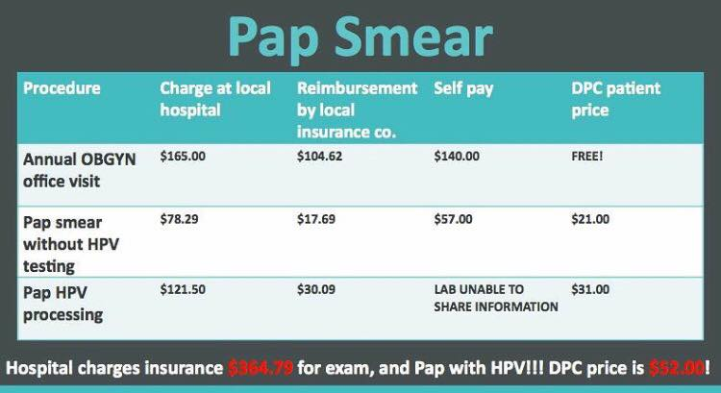

Would you ever go for a service and not know the price ahead of time?
Look at these lab prices charged by a hospital/usually only seen once you get the bill!
Look at our DPC prices, fully transparent, what you see is what you get!
#GHDFC
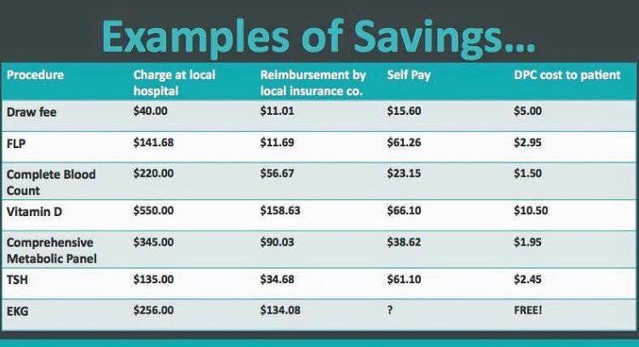

27 year old new patient membership $50.00/month.
Cost of generic med in pharmacy using insurance $100.00.
Cost of same med in our in-office pharmacy $3.83.
He just saved $1,154.04 per year on his medication.
That pays for 23 MONTHS of membership!
Added bonus: Great attention, access!

This 34 year old patient has a $6,000.00 deductible and a $50.00 copay. Boy, it will take her a LOOOONG time to use up the deductible!
For $50.00/month, she has unlimited visits (that last at least 30 minutes) to Dr. Corba and NO COPAYS, discounted meds, labs and imaging!
www.greenhillsdirectfamilycare.com
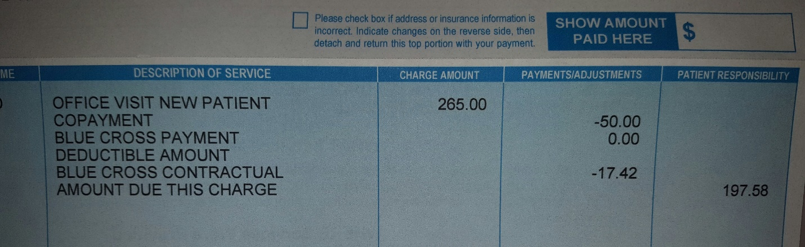

If you are a 29 year old and live in Allentown, PA here are your choices...
Only 7 plans available:
EXAMPLE 1) premium of $300.00/month with $7,100.00 deductible.
EXAMPLE 2) Premium $550.00/month with $1,000.00 deductible.
Copay for PCP visit $40.00.
Annual cost of DPC membership $50.00/month and NO COPAY/NN DEDUCTIBLE!!
For nearly the same price you will get... ACCESS, AFFORDABILITY, ATTENTION unrestricted visits (email, text, phone too)!
Keep that extra money in your back pocket only in case you need it!

Patient Case:
61 year old pays $75.00/month membership (=$2.50/day)
In one hour appointment she gets...
Annual wellness exam ++ SICK VISIT
EKG
Peak flows
Mininebulizer treatment
Blood draw (4 tests for $18.38)
Patient also receives antibiotic, medication for nebulizer, cough med, probiotics for total of $51.11 and does not have to go to pharmacy.
Applies cost for labs and meds to Health Savings Account.
And we give her the tubing and mouthpiece from her treatment to take home.
BOOM!

What are you getting for your $$$??
A 48 year old goes for an office visit with the doctor, spends 30 minutes in the waiting room, 10 minutes with doctor, and has $30.00 copay.
Total spent = $277.58.
This image is the Explanation of Benefits.
Patient will have to pay $247.58 which is applied to $4,000 deductible.
This amount would cover almost 4 months of membership at GHDFC... AND there would be no waiting in the office, patient would have minimum 30 min visit, NO copay!
Not to mention, the patient could text, email, Skype, and call any time after hours for no additional costs
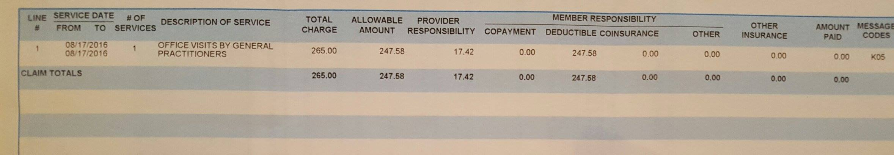

Another awesome GHDFC #DPC Cast Study:
55 year old male presents with chest pain for 1 week duration.
Has high cholesterol, hypertension and family history of heart disease.
He could go to the ER and spend up to 12 hours waiting, and spends thousands for visit, blood work and a stress test.
OR
Dr. Corba can call Cardiology and get him in the SAME DAY for an acute new patient visit with the Cardiologist for $135.00 and a stress test for $75.00! She can also start him on an 81 mg Baby Aspirin for 30 cents/month and refill his BP med, atenolol 50 mg twice daily, for 6 cents/day and his cholesterol med, atorvastatin 10mg once daily for 10 cents/day!

Wow, check out this GHDFC case study:
Patient: 58 year old male with uncontrolled Type 2 Diabetes.
Status: Blood Sugars uncontrolled, now on new medication regimen to bring down his HGA1C.
Dr. Corba has him checking his blood sugars twice daily at varying times. Patient is emailing Dr. Corba his blood sugar diary and she is adjusting his medication remotely! If he needs to be seen, she will get him in within 24 hours or he will be seen for his next regular appointment with NO COPAY, NO WAITING ROOM TIME and a 30 MINUTE VISIT and GET HIS MEDS AT WHOLESALE COSTS!

Talk about AFFORDABLE here at GHDFC!! Check out this case study:
Patient: 45 year old with hypertension, high cholesterol. Needs to take the following medication:
Hydrochlorothiazide 25 mg once daily for blood pressure control = 3 cents/pill.
30 days supply= 90 cents!
Baby aspirin 81 mg once daily for prevention= 1 cent/pill. 30 day supply= 30 cents!
Lipitor (atorvastatin 20mg) for once daily cholesterol= 18 cents/pill 30 day supply= $5.40!
TOTAL for 30 days of 3 meds= $6.60

Knock a ZERO off that bill!
This is a REAL bill for physical therapy. Why pay these fees or have it applied to deductible?
PT with GHDFC= $75.00 initial visit/$50.00 follow up visits with 30-45 minutes of one-on-one individual attention!
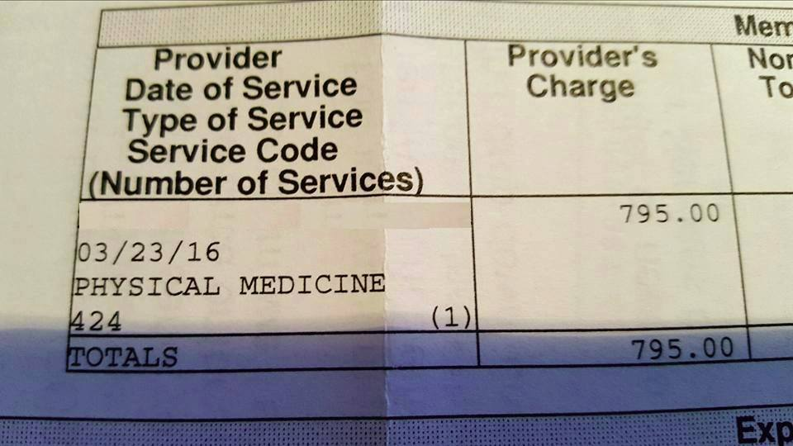

So, this happened:
52 year old for ONE HOUR wellness exam also has back pain and Type 2 diabetes. After not having time to sit down in waiting room because there is, well, NO WAIT, she had the following done:
EKG+four trigger point injections all included for monthly fee of $75.00.
PLUS got her Metformin (for diabetes) 500 mg #180 pills for 90 days for $8.64, AND Ibuprofen (for back pain) 800 mg #30 for $2.07.
Dr. Corba told her to call, email or text if her back pain was not better in the next few days! #DirectPrimaryCare

Get the most out of your time:
46 year old for ADHD eval for which Dr. Corba performs an in-depth 45 minute validated screening. Also asks about abnormal skin lesion while in office (YES, our patients can ask about more than ONE issue per visit). Dr. Corba does biopsy and sends out for pathology.
Procedure and visit for both issues FREE with membership and NO COPAY. Plus, follow ups, calls, texts, email for ADHD included in membership!

Great #GHDFC Case Study for you!
Patient: 35 year old female - history of high blood pressure, high cholesterol, hypothyroidism, depression, on total of 6 medications, looses her job & has no more health insurance.
What happens next? She is forced to stop all of her meds because she cannot afford office visits/medications.
Drum roll please..... #DPC to the rescue!
- All 6 medications costs = $2.50/day ($75/month)
- She needs WEEKLY visits in a month to get her medications re-started and increased.
- Needs an EKG which is FREE!
- All visits covered for monthly membership fee of $50/mo!
Patient finds high deductible plan to cover specialist care and catastrophic issues for low monthly premium and stays with Dr. Corba and DPC for affordable Primary Care services, no copays, unrestricted access and wholesale services. There you have it, folks.

This case study is for our #Medicare followers!
Patient: 72 year old female with high blood pressure, high cholesterol, heart disease & depression.
The high cost of meds puts her in Medicare "Donut Hole"
At GHDFC, she is able to get NINE medications through our in-house pharmacy for the cost of just $29.04 per MONTH!!

Wow, this just happened...
A 25 year old calls for advise from Dr. Corba. They want to go to the ER for a skin abscess which may be infected.
Dr. Corba says "no, meet me in the office!". She incises, drains and packs the abscess in the office in moments!
Cost? FREE with membership
Total time= 45 minutes at GHDFC vs.HOURS in the ER and HUGE BILL!! #DirectPrimaryCare

Here is another GHDFC #DPC case study for you!
Patient: 9 year old, new to GHDFC, has bronchitis and hives
Dr. Corba prescribes the following:
Antibiotic: $1.96
Oral steroids: $1.85
Generic Claritin: $1.80
Monthly membership = $25.00!!!!!
Parents can call, text, email if they need to and return to office as much as needed for..... NO COPAY!

We are filled with great case studies this week!
Patient: 45 year old with hypertension, high cholesterol. Needs to take the following medication:
Hydrochlorothiazide 25 mg once daily for blood pressure control = 3 cents/pill.
30 days supply= 90 cents!
Baby aspirin 81 mg once daily for prevention= 1 cent/pill. 30 day supply= 30 cents!
Lipitor (atorvastatin 20mg) for once daily cholesterol= 18 cents/pill 30 day supply= $5.40!
TOTAL for 30 days of 3 meds= $6.60
Talk about AFFORDABLE here at GHDFC.

Why pay $16.99 + tax for a nasal steroid when you can get one for the discounted price of $4.20? You can actually get FOUR bottles at GHDFC for the in store price!!
